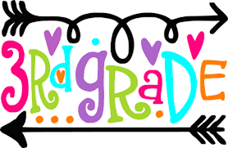
2021-2022 Supply List

- NIV Bible
- 24 No. 2 pencils (sharpened)
- 2 boxes Crayola colored pencils
- 2 composition notebooks
- 2 pairs of scissors
- 2 packs wide ruled notebook paper
- 1 expanding file folder (zip up)
- 1 pack of Crayola Markers
- 2 blue & 2 red ink pens
- 1 large box of crayons
- 1 pack thick dry erase markers (color)
- 2 packs of copy paper
- 10 glue sticks
- 1 bottle of glue
- 1 packs of note cards (4x6)
- 2 large pink erasers
- 1 supply box
- 2 boxes of tissues
- 2 bottles of hand sanitizer
- 2 containers of bleach wipes
- 2 rolls of paper towels
- 1 box of gallon size baggies
- 2 cans of sanitizing spray
- 1 book bag and lunchbox
- Student Planner

