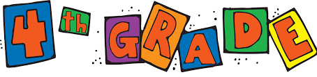

2021-2022 SCHOOL SUPPLY LIST
- 1 NIV Bible
- 1 pencil box
- 1 zipper pencil pouch (for markers and colored pencils)
- 1 backpack
- 1 lunchbox
- 24 #2 pencils, yellow only
- 24 glue sticks
- 2 pink block erasers
- 1 pair child- sized pointed scissors
- Accordian file
- 10 marble composition books
- 2 packages of dry erase markers (not neon colors)
- 2 yellow highlighters
- 24 pack good quality colored pencils
- 2 red pens
- 1 pack of lined index cards
- 1 box of good quality markers (thin)
- 2 boxes of tissues
- 2 containers of Lysol wipes
- 1 container of Lysol
- 1 package of paper towels
- 2 packages of copy paper

Some supplies may need to be replenished throughout the year.

